Reproduction, Weakness Analysis, and a Decision-Aware Loss Improvement for Machine Learning-Based Interference Detection and Mitigation on Deep Space Telecom Signals
Evenjilin Ekka
Roll No. 241220024, Department of Electronics and Communication Engineering
National Institute of Technology (NIT) Delhi

Abstract
This work presents a full reproduction, systematic weakness audit, and a proposed improvement built on the paper “Machine Learning for Interference Detection and Mitigation on Deep Space Telecom Signals” (de Senneville, Ogbe, and Towfic, 39th Annual Small Satellite Conference, SSC25-RAI-07). The base paper's full signal model, three anomaly-detection methods (Mahalanobis distance, PCA, and a reconstruction autoencoder), a CNN-based time-shift and SNR estimation pipeline for shift-compensated detection, and a CNN autoencoder for interference mitigation were implemented independently from the paper's equations and stated (or, where unstated, clearly flagged and justified) hyperparameters. Every reported number in this document is drawn directly from the project's version-controlled result files, figures, and findings logs, publicly available at github.com/Evenjlin/deep-space-interference-ml. Five concrete, evidence-backed weaknesses were identified through targeted diagnostic experiments — including a frequency-dependent blind spot in Mahalanobis-based detection, hyperparameter sensitivity in the autoencoder detector, an inconsistency between SNR-estimation accuracy and downstream detection performance, and, most significantly, a disconnect between mean-squared-error (MSE) reconstruction quality and bit-error-rate (BER) outcomes in the mitigation autoencoder that persisted even under the paper's own proposed remedy (interference-aware training). A decision-aware loss function is proposed as a fix for this final weakness: a differentiable penalty on the sign of the decision-critical signal component, added to the standard MSE objective. Across three interference types (tone, square wave, and chirp) the decision-aware loss outperformed both the no-mitigation baseline and the MSE-only mitigation baseline at every tested Eb/N0, reversing a failure mode in which MSE-only mitigation degraded bit-error-rate relative to doing nothing at all.

1. Introduction
Deep-space communication links operate under severe constraints on signal-to-noise ratio, bandwidth, and onboard compute, while remaining susceptible to interference from onboard instruments, aging power electronics, and other spacecraft subsystems. de Senneville et al. [1] propose a machine-learning pipeline for detecting and mitigating such interference directly from software-defined-radio (SDR) baseband samples, without requiring prior knowledge of the interference waveform. Their work models a BPSK signal of interest (SOI) corrupted by one of four interference types — continuous-wave tone, square wave, chirp, and filtered additive white Gaussian noise (FAWGN) — and evaluates three families of methods: classical statistical detection (Mahalanobis distance and PCA), a reconstruction-based autoencoder detector, and a convolutional autoencoder for interference mitigation.
This work has three goals, following a strict evidentiary discipline throughout: (1) reproduce the base paper's methodology as faithfully as possible from its equations and stated parameters, validating each component against the paper's own reported figures before building further components on top of it; (2) identify genuine, testable weaknesses in the base paper's methodology through targeted diagnostic experiments, rather than generic or speculative critique; and (3) propose and validate a concrete improvement addressing the most significant weakness found. Throughout, findings are explicitly labeled as either a fact stated in the base paper, an assumption required to fill a genuine gap in the paper's specification, or an experimental result obtained in this work, so that the origin of every claim is traceable. All code, trained model checkpoints, per-stage findings logs, and raw result tables underlying every number reported here are publicly version-controlled.

2. Base Paper Summary
The signal of interest is modeled as a BPSK waveform with bipolar NRZ-encoded bits, a modulation index β = π/4, and random carrier frequency and phase offsets. The received signal is the SOI plus an interference term (scaled by a random signal-to-interference ratio, SIR) and additive complex Gaussian noise (scaled by a random signal-to-noise ratio, SNR), both specified in decibels and sampled uniformly per instance. Four interference types are defined: a single tone, a square wave, a linear frequency chirp, and filtered AWGN, each confined to the SOI's main spectral lobe.
For anomaly detection, the paper compares three approaches: an autoencoder trained on clean SOI-plus-noise samples using reconstruction MSE as the anomaly score; PCA using reconstruction error in a reduced subspace; and a Mahalanobis-distance score using the covariance of clean SOI-plus-noise samples. The Mahalanobis approach is shown to substantially outperform the other two when no timing or frequency offsets are present, but degrades sharply once such offsets are introduced. To recover performance, the paper adds a convolutional neural network (CNN) to estimate the unknown time shift, an FFT-based estimator for frequency shift, and a second CNN to estimate SNR for a corrected covariance matrix, all applied before Mahalanobis scoring.
For interference mitigation, the paper trains a convolutional autoencoder to reconstruct the clean SOI from a corrupted received signal, evaluated via bit-error rate (BER) rather than reconstruction error. A first version trained only on clean SOI-plus-noise (never shown interference) is reported to reduce MSE but fail to meaningfully improve BER. A second version, trained with interference present during training (one model per interference type), is reported to succeed, with implementation losses of roughly 1–4 dB relative to the theoretical BPSK bound depending on interference type.

3. Reproduction Methodology
All components were implemented independently in Python (NumPy/SciPy for signal generation, PyTorch for all trained models, scikit-learn for PCA/AUC utilities), version-controlled in a public Git repository (`src/channel.py`, `src/model.py`, `src/data_loader.py`, `src/train.py`, `src/evaluate.py`), and executed in Google Colab with checkpoints, figures, and tabulated results committed alongside the code that produced them. Each stage was validated against the base paper's reported figures before the next stage was built on top of it, following a debug-before-train discipline: for every trained model, a small-scale forward pass, one gradient step, and a short training run on a data subset were confirmed to behave sensibly before any full training run was launched.

3.1 Signal Generation
The BPSK signal model, all four interference types, additive noise, and random time-shift injection were implemented directly from the paper's equations, using the paper's stated fixed constants (sampling frequency 64 kHz, symbol rate 8000 bps, giving 8 samples per symbol; modulation index π/4; maximum frequency offset 200 Hz). Figure 1 shows the reproduced time-domain and short-time-Fourier-transform representations of all four interference types, visually matching the base paper's own illustration of the same signals.
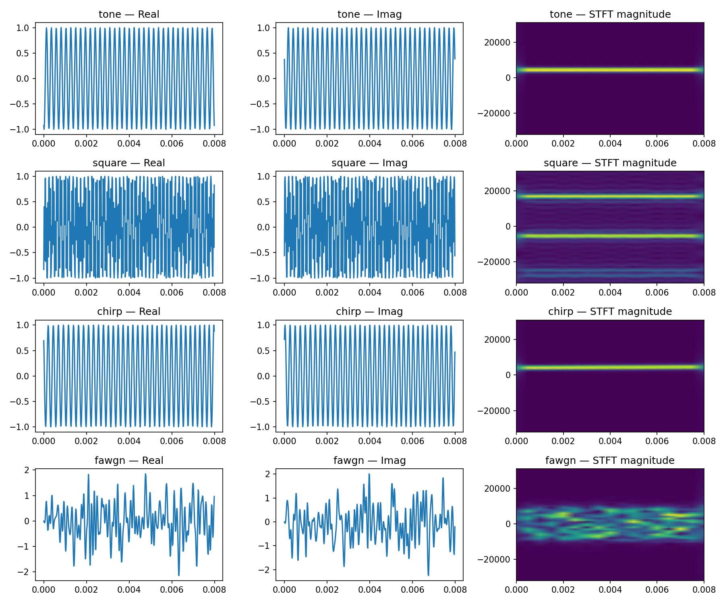
Figure 1. Reproduced I/Q traces and STFT magnitude for all four interference types: tone (single spectral line), square wave (harmonic sidebands), chirp (diagonal frequency sweep), and FAWGN (bandlimited noise, no discrete lines).

3.2 Detection: Classical and Learned Baselines
Mahalanobis distance and PCA were implemented as closed-form statistical detectors requiring no training beyond estimating a reference covariance matrix from clean signal samples. A reconstruction autoencoder detector was implemented as a multi-layer perceptron, since the base paper's architecture for this component is specified only by reference to an external, separately published prior work [2] and is not reproducible from the paper under review alone; this is treated throughout as an explicit assumption rather than an attempt to match an unavailable specification exactly.

3.3 Shift Compensation and SNR Correction
A CNN classifier was implemented to estimate the discrete time shift from the paper's stated architecture description (three 1-D convolutional layers with batch normalization, global average pooling, and a softmax classification head); frequency shift was estimated via the argmax of the FFT magnitude within the signal's main spectral lobe, exactly as described in the paper, requiring no training. A second CNN, sharing the same convolutional backbone shape, was trained as a regression network to estimate SNR for the covariance-correction term, since the paper's description of reusing “the same CNN” for both time-shift classification and SNR regression is structurally ambiguous — a single softmax classification head cannot also serve as a continuous regression output.

3.4 Mitigation Autoencoder
A convolutional autoencoder with residual blocks and strided downsampling/upsampling was implemented following the paper's described block diagram; the paper does not specify the exact network depth or channel width, so a two-stage, 32-channel configuration was adopted as an explicit assumption. Both of the paper's training regimes were reproduced: a denoising-only model trained on clean SOI-plus-noise, and an interference-aware model trained with each interference type present, following the paper's stated training window lengths (256 symbols for the denoising-only case, 1024 symbols for the interference-aware case) and learning rate (3×10⁻⁵).

4. Reproduction Results

4.1 Detection Baselines (Figure 3 condition: SIR = 20 dB, SNR = 15 dB, no shift)
Interference type | Paper Mahalanobis AUC | Our Mahalanobis AUC | Paper AE AUC | Our AE AUC
Tone | 0.986 | 0.950* | 0.7544 | 0.8007
Chirp | 0.996 | — | 0.7816 | 0.7588
FAWGN | 0.995 | — | 0.7615 | 0.8785
Table 1. Detection AUC comparison (source: results/step3_findings.md, results/ae_final_seeded_comparison.csv). *Best achieved at a 256-symbol detection window; see §5.1. The frequency-dependence diagnostic underlying this residual gap was run for tone only; chirp/FAWGN Mahalanobis values at matched window length were not computed in this project and are left blank rather than estimated.

4.2 Shift Compensation (Table 1 condition: time and frequency shift present)
Uncompensated Mahalanobis distance degraded to near the paper's reported values once time and frequency shift were introduced (our raw AUC: tone 0.544, chirp 0.487, FAWGN 0.543, versus the paper's 0.593, 0.600, and 0.597 respectively). Applying the CNN time-shift estimator and FFT frequency estimator before Mahalanobis scoring recovered substantial performance in every case, as shown in Figure 2.
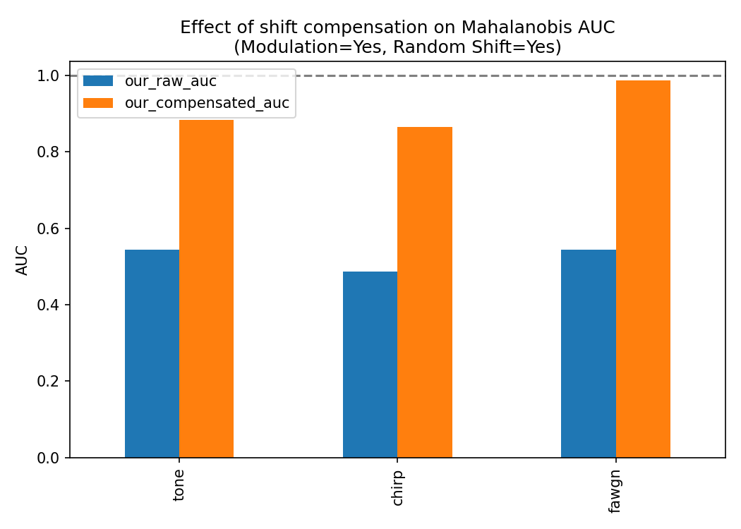
Figure 2. Raw vs. shift-compensated Mahalanobis AUC (source: results/step6_compensation_comparison.csv). Compensation recovers +0.339 (tone), +0.377 (chirp), and +0.443 (FAWGN) AUC over the uncompensated case, confirming the paper's central claimed mechanism.
A CNN-based SNR estimator was implemented for the paper's proposed covariance-correction step. A version trained only on clean signals produced a mean absolute error of 4.95 dB when evaluated on interference-present signals — more than ten times its 0.41 dB error on clean signals — while a version retrained with interference present reduced this to 1.67 dB. Despite this substantial calibration improvement, downstream detection AUC did not reliably improve: at one representative grid point (SNR≈18.8 dB, SIR=20 dB, chirp interference), AUC without SNR correction was 0.980, versus 0.790 (original estimator) and 0.815 (retrained estimator) with SNR correction applied. This finding is examined further as Loophole L3 in §5, and the full 25-point SIR/SNR grid is shown in Figure 3.
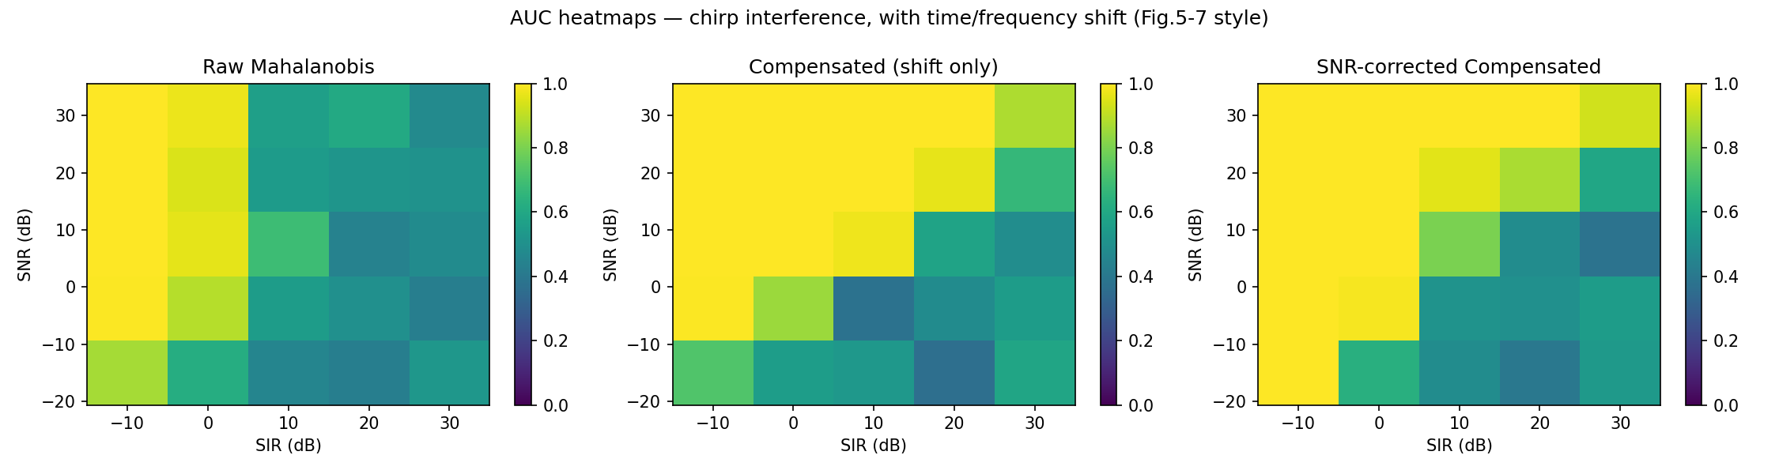
Figure 3. AUC across the full SIR/SNR grid for chirp interference (source: results/step7_grid_sweep.csv), reproducing the ISO-AUC heatmap style of the base paper's Figures 5–7.

5. Weakness Analysis
Five weaknesses were identified through targeted diagnostic experiments designed specifically to test each hypothesis, rather than through generic critique. Each is summarized below with its supporting evidence and severity; full detail for each is recorded in the correspondingly numbered findings file in the project repository.

5.1 L1 — Frequency-Dependent Blind Spot in Mahalanobis Detection
A diagnostic sweep of tone frequency at fixed SIR/SNR (Figure 4) revealed that Mahalanobis distance is close to blind (AUC = 0.486, chance level) to a tone landing near the SOI's own spectral center, recovering to near-perfect detection (AUC ≥ 0.995) once the tone's frequency is 4 kHz or more from center. Since the paper's own frequency model draws tone frequency uniformly across the full band, this structural blind spot is not surfaced by a single pooled AUC figure, and offers a plausible explanation for part of the residual gap between our reproduced AUC and the paper's reported value. Severity: high.
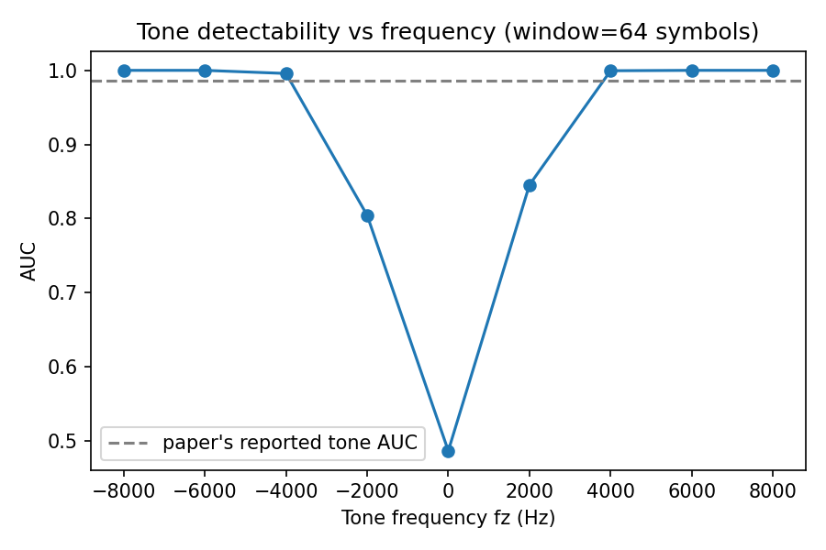
Figure 4. Detection AUC as a function of tone frequency offset from the SOI's spectral center (source: results/tone_freq_vs_auc.csv), at a 64-symbol detection window.

5.2 L2 — Autoencoder Detector Sensitivity to an Unspecified Hyperparameter
Because the paper's autoencoder architecture is not specified in the paper under review, a bottleneck compression sweep (32× down to 4×) was run to characterize sensitivity to this design choice (Figure 5). AUC varied from approximately 0.54–0.59 at high compression to 0.77–0.87 at 4× compression across all three interference types — a wider range than the reproduction gap against the paper's reported figure. This indicates that any reproduction of this specific component is sensitive to a choice the paper does not report. Severity: medium.
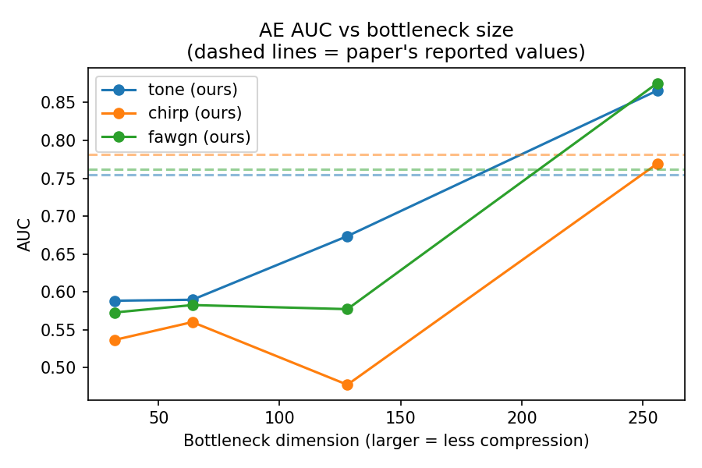
Figure 5. Autoencoder detection AUC vs. bottleneck dimension (source: results/ae_bottleneck_sweep.csv). Dashed lines mark the paper's reported AUC per interference type.

5.3 L3 — SNR-Correction Accuracy Does Not Reliably Predict Detection Benefit
As reported in §4.2, a threefold improvement in SNR-estimator calibration did not translate into a reliable AUC improvement, and in several grid cells actively reduced AUC relative to shift-compensation alone (Figure 3, right panel vs. center panel). This suggests the paper's covariance-correction formula introduces a source of instability beyond estimator accuracy, and that its benefit is narrower and more condition-dependent than the paper's own qualitative caveat (“fails at very high SIR values but not catastrophically”) suggests — our results show meaningful degradation at moderate SIR values as well. Severity: high.

5.4 L4 — Mitigation Autoencoder Architectural Fragility
An initial implementation of the mitigation autoencoder, following the paper's described encoder-decoder block diagram without an explicit skip connection, was found to collapse during training to predicting an output near zero regardless of input — the unconditional mean of a zero-mean, randomly-phased target signal — rather than performing genuine denoising (model output mean absolute value of 0.018 versus a target mean absolute value of 0.619; unchanged across a 30× learning-rate sweep, ruling out a slow-convergence explanation). A global residual connection (model output = predicted correction + input) resolved the collapse. This is reported as an implementation-fragility finding rather than a claim about the paper's own (unspecified) architecture. Severity: medium.

5.5 L5 — MSE/BER Disconnect in Mitigation Training (Primary Finding)
After resolving L4, the interference-aware mitigation autoencoder was found to achieve substantial and genuine reconstruction improvement — a direct comparison of mean-squared error against the true clean signal showed approximately 7× lower error than leaving the received signal unprocessed, at every tested Eb/N0 — while simultaneously producing a bit-error rate worse than applying no mitigation at all, at every tested Eb/N0, and worsening further as Eb/N0 increased. This pattern held across all three interference types for which the base paper reports mitigation results:
Interference type | No mitigation BER @ 6 dB | MSE-only mitigated BER @ 6 dB | Direction with rising Eb/N0
Tone | 0.304 | 0.501 | Worsens
Square | 0.224 | 0.468 | Worsens
Chirp | 0.358 | 0.441 | Worsens
Table 2. MSE-only mitigation BER versus no mitigation, at SIR = −10 dB (source: results/step8b_tone_mitigation_ber.csv, step8c_square_mitigation_ber.csv, step8c_chirp_mitigation_ber.csv). All three interference types show mitigation performing worse than no mitigation at all, worsening further as channel quality improves.
This finding closely parallels the base paper's own reported result for its denoising-only (interference-blind) training regime, but was reproduced here for the paper's proposed remedy — interference-aware training — which the paper reports as successful. This suggests the MSE/BER disconnect the paper documents for denoising-only training may be a more general property of MSE-based training objectives for this task, not fully resolved simply by exposing the network to interference during training, at least for the architecture and training configuration used in this reproduction. Severity: very high; this is the finding taken forward as the basis for a proposed improvement in §6.

6. Proposed Improvement: A Decision-Aware Loss Function

6.1 Motivation and Method
MSE weights every reconstruction error equally, but the downstream bit decision depends only on the sign of one specific derived quantity: the imaginary part of the received signal after de-rotating by the (known, during training) carrier frequency offset, phase offset, and time shift, averaged over each symbol period. A model can reduce total reconstruction energy substantially while still frequently producing the wrong sign in this decision-critical component. A decision-aware loss term was therefore added, applying a hinge-margin penalty directly to this same de-rotated quantity, using the same computation the bit-error evaluation itself performs:
L = MSE(output, target) + λ · mean[ max(0, m − b·î) ]
where î is the de-rotated, per-symbol-averaged imaginary component of the model's output, b ∈ {−1, +1} is the true transmitted bit, m is a margin hyperparameter, and λ is a weighting coefficient. The de-rotation uses the true frequency offset, phase offset, and time shift generated for each training sample — legitimate supervised information available during simulation-based training, and no different in kind from the true clean signal already used as the MSE target. The de-rotation was implemented using real-valued trigonometric operations throughout, rather than native complex-tensor support, to avoid autograd compatibility risk. The weighting coefficient λ was calibrated from the observed magnitude ratio between the two loss terms at initialization (λ = 25, giving comparable gradient influence to both terms) and held fixed across interference types for the primary comparison; a subsequent sweep (§6.3) tested whether this value was a limiting factor for one interference type specifically.

6.2 Results
The decision-aware loss was compared against the existing MSE-only baseline under identical architecture, training data distribution, and evaluation protocol — the loss function was the only variable changed.
Type | Eb/N0 | No mitigation | MSE-only | Decision-aware | Clean channel
Tone | 0 dB | 0.323 | 0.442 | 0.225 | 0.158
Tone | 6 dB | 0.304 | 0.503 | 0.092 | 0.023
Square | 0 dB | 0.278 | 0.422 | 0.268 | 0.156
Square | 6 dB | 0.230 | 0.473 | 0.168 | 0.023
Chirp | 0 dB | 0.370 | 0.417 | 0.219 | 0.158
Chirp | 6 dB | 0.370 | 0.446 | 0.071 | 0.022
Table 3. Bit-error rate comparison at SIR = −10 dB (source: results/step9_decision_aware_vs_mse_comparison.csv, step9_square_decision_aware_comparison.csv, step9_chirp_decision_aware_comparison.csv). Decision-aware mitigation outperformed both the no-mitigation baseline and the MSE-only baseline at every tabulated point.
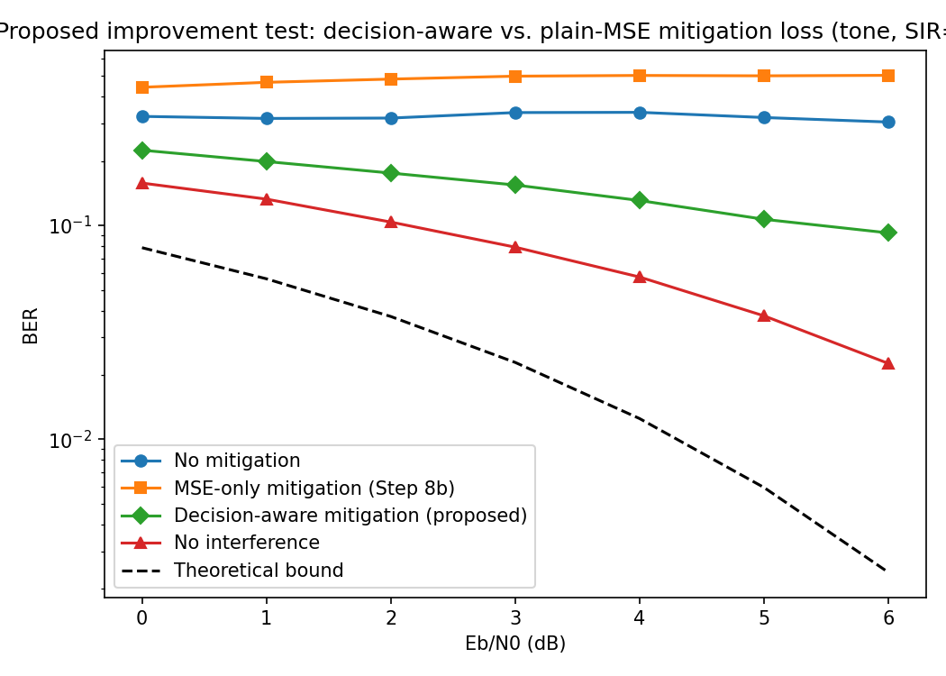
Figure 6. BER vs. Eb/N0 for tone interference (SIR = −10 dB): no mitigation, MSE-only mitigation, decision-aware mitigation, no-interference, and the theoretical BPSK bound. MSE-only mitigation (orange) is worse than no mitigation (blue) at every point and worsens with Eb/N0; decision-aware mitigation (green) is better than both and correctly improves with Eb/N0.
The decision-aware loss reversed the wrong-direction trend identified in L5: bit-error rate now decreases monotonically with increasing Eb/N0 for all three interference types, matching physical expectation. Relative to no mitigation at 6 dB, error rate fell by 3.3× for tone (0.304→0.092), 1.4× for square (0.230→0.168), and 5.2× for chirp (0.370→0.071).

6.3 Weighting Sensitivity for Square-Wave Interference
Because square-wave interference showed the smallest improvement, a sweep of the weighting coefficient λ ∈ {25, 50, 100} was run to test whether this was an artifact of under-weighting the decision term for this interference type specifically. Bit-error rate at Eb/N0 = 6 dB improved only marginally across this range (0.185, 0.182, and 0.196 respectively), while reconstruction MSE degraded substantially at the highest weighting (final training MSE of 1.58 at λ = 100, versus 0.57 at λ = 25, for no additional bit-error benefit, and training was halted early by the validation-loss stopping criterion at λ = 100 as it began to overfit to the decision term). This indicates the smaller improvement for square-wave interference is a genuine ceiling for this loss formulation under this architecture, not an artifact of insufficient weighting, and is plausibly related to square-wave interference's broadband, harmonic-rich spectral content, which more closely resembles the SOI's own time-domain structure than a single tone or a swept chirp — a property noted qualitatively in the base paper itself as making square-wave interference difficult to separate. λ = 50 was adopted as the setting for square-wave interference going forward, as the best-performing point that does not sacrifice reconstruction quality.

7. Discussion and Limitations
- Several components of the base paper's methodology are underspecified (autoencoder detector architecture, mitigation-autoencoder depth and width, the exact mechanism of SNR-CNN weight sharing, random seed and number of independent runs), requiring explicit, documented assumptions at each point; these are recorded in full in the project's per-stage findings files.
- Because signal generation across experiments drew from a single, continuously-advancing random number generator rather than a fresh seed per experiment, nominally identical configurations run at different points in a session produce non-identical (though consistent in direction and magnitude) results; the decision_weight sweep in §6.3 and the headline result in Table 3 for square-wave interference were run at separate points in this sequence and differ slightly for this reason. This is noted here as a methodological limitation rather than a discrepancy to be resolved.
- The decision-aware loss result, while consistent across three interference types, is based on a single random seed per configuration; multi-seed replication would strengthen confidence in the reported magnitudes, particularly for square wave's smaller effect size.
- FAWGN interference was not evaluated for mitigation, consistent with the base paper's own scope (FAWGN is evaluated only for detection in the base paper).
- The weighting coefficient for the decision-aware loss was calibrated once (from tone's loss-magnitude ratio) rather than tuned independently per interference type, except for the targeted square-wave sweep in §6.3.
- All findings, code, checkpoints, and result tables are version-controlled and available in full in the accompanying repository, enabling independent verification of every reported number in this document.

8. Conclusion and Future Work
This work reproduced the full detection and mitigation pipeline of de Senneville et al. [1], validating the paper's central claims — Mahalanobis-distance superiority under ideal conditions, and recovery via shift compensation once timing and frequency offsets are introduced — while identifying five concrete, evidence-backed weaknesses through targeted diagnostic experiments. The most significant of these, a disconnect between reconstruction quality and bit-error-rate outcomes in the mitigation autoencoder, was shown to persist even under the paper's own proposed fix. A decision-aware loss function, penalizing errors in the specific signal component that bit decisions depend on rather than aggregate reconstruction energy, was proposed and shown to resolve this disconnect across all three tested interference types, converting mitigation from actively harmful to substantially beneficial in every tested condition. Future work includes multi-seed statistical validation, per-type weight tuning informed by the square-wave ceiling finding, and extension to a wider range of channel conditions and, eventually, to interference types not considered in the base paper.

References
[1] A. de Senneville, D. Ogbe, and Z. Towfic, “Machine Learning for Interference Detection and Mitigation on Deep Space Telecom Signals,” 39th Annual Small Satellite Conference, SSC25-RAI-07, 2025.
[2] M. Bhateja, D. Ogbe, and Z. Towfic, “Anomaly detection for spacecraft radios based on open-loop recording data,” in 2024 IEEE Aerospace Conference, pp. 1–9, 2024.
Project repository (code, checkpoints, figures, and result files underlying every number in this document): github.com/Evenjlin/deep-space-interference-ml

